

Hato Anaru o Te Parehua
Founded 1840
Order of Service

14 April 2017

Good Friday

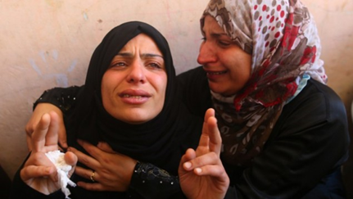

Photo: Mohammed Abed

Welcome to St Andrew’s on The TerracE
Wherever you are on your faith's journey,
wherever you have come from and wherever you are going to,
whatever you believe, whatever you do not believe, you are welcome here.
Please join in the congregational responses printed in bold italics.
Please stand if you are able, for the hymns and the offering prayer.
We will sing the hymns without announcement.
To use the loop system in the church, turn your hearing aids on to the appropriate setting.
Please note your nearest fire exit.
The church and hall have been earthquake strengthened. In an earthquake: drop, cover and hold.
MUSIC Threnos, Tavener *
Cello M Barley
GATHERING
Today we enter again into the old stories of deaths and renewals,
of betrayal, injustice and violence against
the gentler powers of Truth, Justice and Love.
We proclaim with Jesus that despite appearances
these are the powers that ultimately triumph.
As we gather again this Good Friday at the foot of the cross
We bring our own sorrowful stories of woundings and pain,
and those of the wider world to mingle here
with the story of Jesus and his family and friends
and entrust them all to the God of Love.

PROCESSIONAL HYMN ‘How could a God whose name is love’
Words: © Ruth Duck. Tune: Kingsfold WOV500
How could a God whose name is love
seek blood to pay sin’s price?
Are torture, shame, and senseless death
a holy sacrifice?
Each violent crime is tragic loss;
how could it be God’s will?
How can we glorify the cross
when victims suffer still?

Did Jesus come as God’s own child
to share each human tear?
Did Jesus die in speaking truth
that rulers will not hear?
If Wisdom hangs upon a tree,
what, then, are we to do?
Must we, like Jesus, risk our lives
for what is just and true?
In Jesus Christ we meet a God
whose love embraces all,
who weeps when children are abused,
who hears each sparrow fall.
When grace is ancient as the earth,
we need not worship death.
So let us live in tender care for all
whom Love gives breath.

WELCOME
Kia ora tatou.
Kia ora.

PRAYER
Loving God, to accompany another through their suffering
to their death takes loving courage.
It feels powerless. We struggle.
We can feel useless and helpless.
Help us recognise that the gift of presence
is beyond price to the one we love.
Today in memory and imagination
we accompany our friend Jesus on his final journey,
and with him all who suffer,
in our own community and in the wider world.

FIRST STATION - Jesus is condemned to death Mark 15: 1-5, 11-15

Meditation: Jenny Simpson
Prayer
We pray for those imprisoned without fair trial, for those who live by a way incomprehensible to most and are mocked, for those who are different and so condemned to die. And for those who make a mistake and betray out of fear.
Compassionate God, may we and all the world know your presence.
Sung Response AA50 ‘God of freedom, God of justice’
Words: Shirley Murray vs 1&2
Tune: Picardy, French Traditional carol medley 17th – 18th C
God of freedom, God of justice,
you whose love is strong as death,
you who saw the dark of prison,
you who knew the price of faith,
touch our world of sad oppression,
with your Spirit’s healing breath.

SECOND STATION – Jesus takes up his cross Mark 15: 16-20
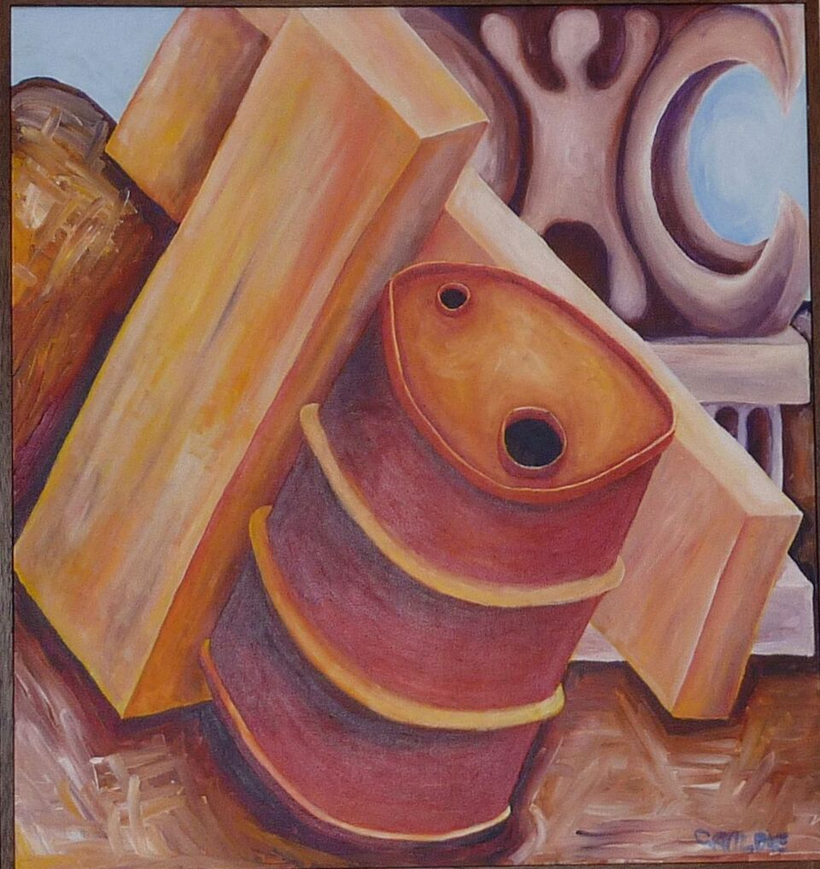
Meditation: Wendy Matthews
Prayer
There is much violence and injustice in our modern world.
May we as individuals and as a community have the courage and strength to stand up against violence and injustice in our neighbourhood, our city, our country and our world.

Compassionate God, may we and all the world know your presence.

Sung Response
Rid the earth of torture’s terror,
you whose hands were nailed to wood;
hear the cries of pain and protest,
you who shed the tears and blood;
move in us the power of pity
Restless for the common good.

THIRD STATION – Jesus falls for the first time Isaiah 53: 2
Meditation: Judith Cowley
Prayer
God grant me the understanding and compassion towards the fallen and help me remember that I am one of them.
Compassionate God, may we and all the world know your presence.

Sung Response Words: Fiona McDougal
When in deep despair we have fallen,
you who walked the stony road,
strengthen us to walk one step further,
you who bore a heavy load,
friends and whanau can sustain us,
though for now our head is bowed.

FOURTH STATION – Jesus meets his mother Luke 2: 22, 34, 35

Meditation: Valerie Rhodes
Prayer
We pray for all parents who have lost a child or have seen their loved child take a different path from the one they had hoped for them. Ease their pain and comfort them.
Compassionate God, may we and all the world know your presence.

Sung Response Words: Fiona McDougal vs 1&2
Tune: Affliction, Julian Bray
With mother-love a heart will break
in helplessness and grief
to watch a child who’s suffering
unable to relieve.

FIFTH STATION – Simon helps Jesus to carry his cross Mark 15:21
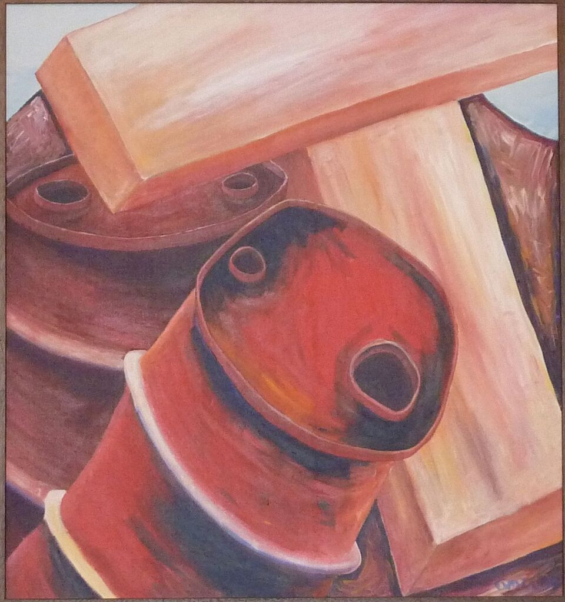
Meditation: Jon Schrader
Prayer
We pray for the millions in our world whose suffering is caused by the inhumanity of other human beings. And for those in our city and our community, who are in need of
support, love and understanding. Let us pray that we heed anew Christ’s call to be his hands and feet, active and loving, people of the Way.
Compassionate God, may we and all the world know your presence.

Sung Response
Confronted with another’s need
their burden we can share
stand with them in their suffering
by being present there.

SIXTH STATION – Veronica wipes the face of Jesus Matthew 25: 35-36, 40

Meditation: Paul Satherley
Prayer
We pray for those of us who feel compassion and quickly help, may we be humble. And for those of us who feel compassion but hesitate, may we know peace.
Compassionate God, may we and all the world know your presence.

Sung Response HIOS 106 ‘O God I cry to you in pain’ vs 2 & 4
Words: Shirley Murray
Give me the strength to face my ills
to trust in skill and care
to bless the hands that help me heal
and find your Spirit there.

Within the comfort and the love
that human touch can give,
restore in me a larger sense
of what it is to live.

SEVENTH STATION – Jesus falls the second time Isaiah 53: 3
Meditation: Tony Pears

Prayer
We pray for people everywhere who are rejected and despised for who they are, or for the label they are given, especially children.
And for those in places where coming to believe in Jesus and follow Jesus most often means
painful rejection and suffering.
Compassionate God, may we and all the world know your presence.
Sung Response HIOS 52 ‘God who weeps’ vs 1&2
Words – Marnie Barrell. Tune: Barry Brinson, Lacrimosa
God who weeps when we are weeping
maker, lover, friend of all,
we commit into your keeping
those who suffer, struggle, fall.
Plant the seeds of peace inside us
in these days of fateful choice;
let your word and wisdom guide us
as we listen for your voice.

EIGHTH STATION – Jesus meets the women of Jerusalem Luke 23: 27-28
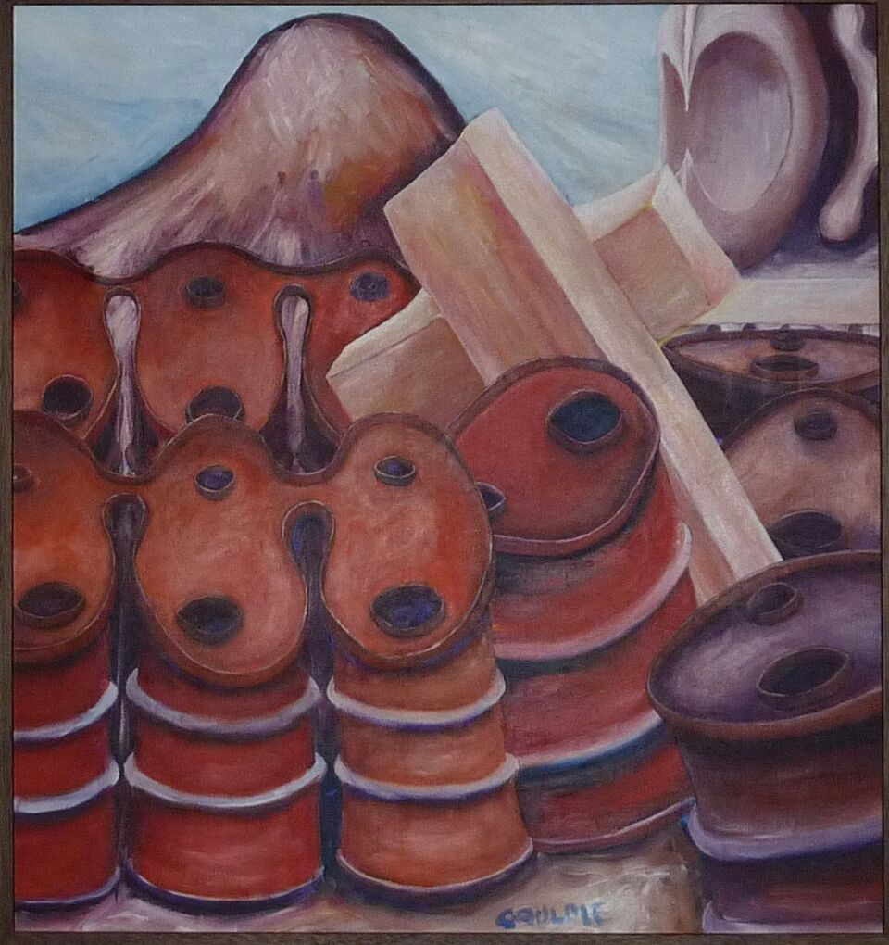
Meditation: Frances Porter
Prayer
Let us remember with gratitude the generations of women, anonymous in History, who walked, often on tired feet, preparing and serving food, carrying water and fuel, clearing away, and tidying up while bearing and nurturing LIFE itself.
Compassionate God, may we and all the world know your presence.
Sung Response
Christ, enduring hate and violence,
hounded to a martyr’s death
calmly meeting taunts with silence,
speaking peace with your last breath;
peace, courageous and demanding,
binds us as we walk your way.
May our wills, at your commanding
turn to acts of peace today.

NINTH STATION – Jesus falls for the third time Isaiah 53: 7

Meditation: Barrie Keenan
Prayer
We pray for ourselves when we fall – give us the strength to get up and try again,
for others when they fall, that we might help them,
for our community that we might learn from the falls that we have taken and the mistakes made.
Compassionate God, may we and all the world know your presence.
Sung Response: AA45 ‘Give Thanks for Life’ vs 2
Words: Shirley Murray. Tune: Sine Nomine. WOV384
Give thanks for those
who made their life a light
caught from the Christ-flame,
bursting through the night,
who touched the truth, who
burned for what is right,
Alleluia!
TENTH STATION – Jesus is stripped of his clothes Mark 15: 22-24
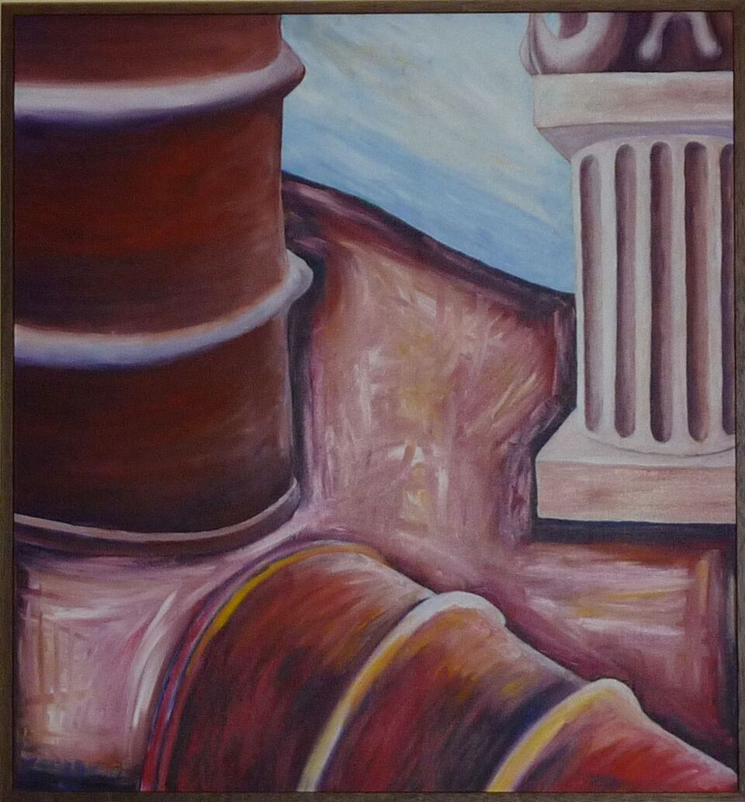
Meditation: Gabrielle Ruben
Prayer
Though it will always be difficult
to find the words for what you feel
may you find ease in that awkwardness...
somewhere in us a dignity presides
that is more gracious than the smallness
that fuels us with fear and force
a dignity that trusts the form a day takes.
harness its force to cross the boundaries
that would confine you.
Compassionate God, may we and all the world know your presence.

Sung Response COC 4 ‘All who would see God’s Greatness’ vs 1
Words: Marnie Barrell. Tune: Obeisance, Ian Render
If you would share God’s riches
Draw near, reach out and touch;
God had only love to offer,
Enough for us, and too much.
See now God’s treasure, made so poor,
Naked the God that we adore.

ELEVENTH STATION – Jesus is nailed to the cross Luke 23: 35-38
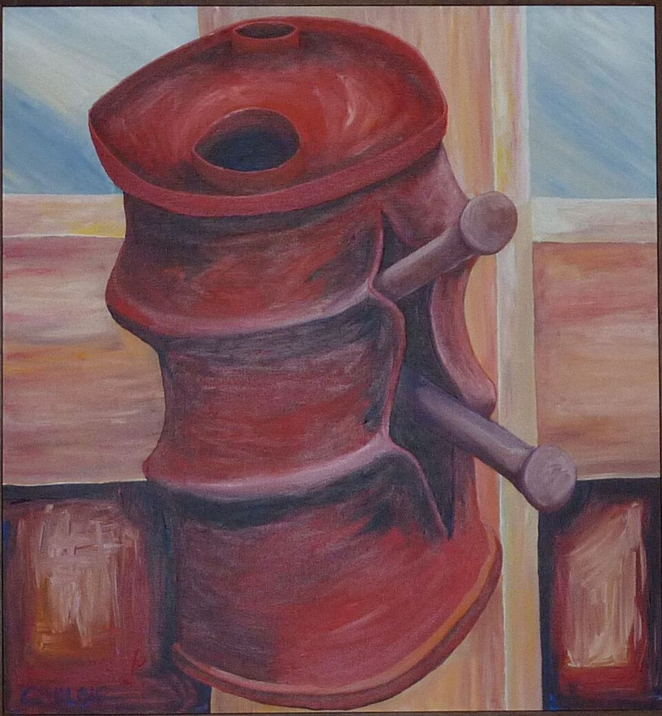
Meditation: Margaret Megwyn
Prayer
We pray for those who feel mocked or marginalised.
For those suffering from neglect, loneliness and disruption.
Compassionate God, may we and all the world know your presence.

Sung Response
Stand in the holy silence,
while earth with heaven sings
that here now for our beholding
is love that upholds all things.
Strange is this love that draws us near;
glory of God among us here.

TWELFTH STATION – Jesus dies on the cross Luke 23: 44-46
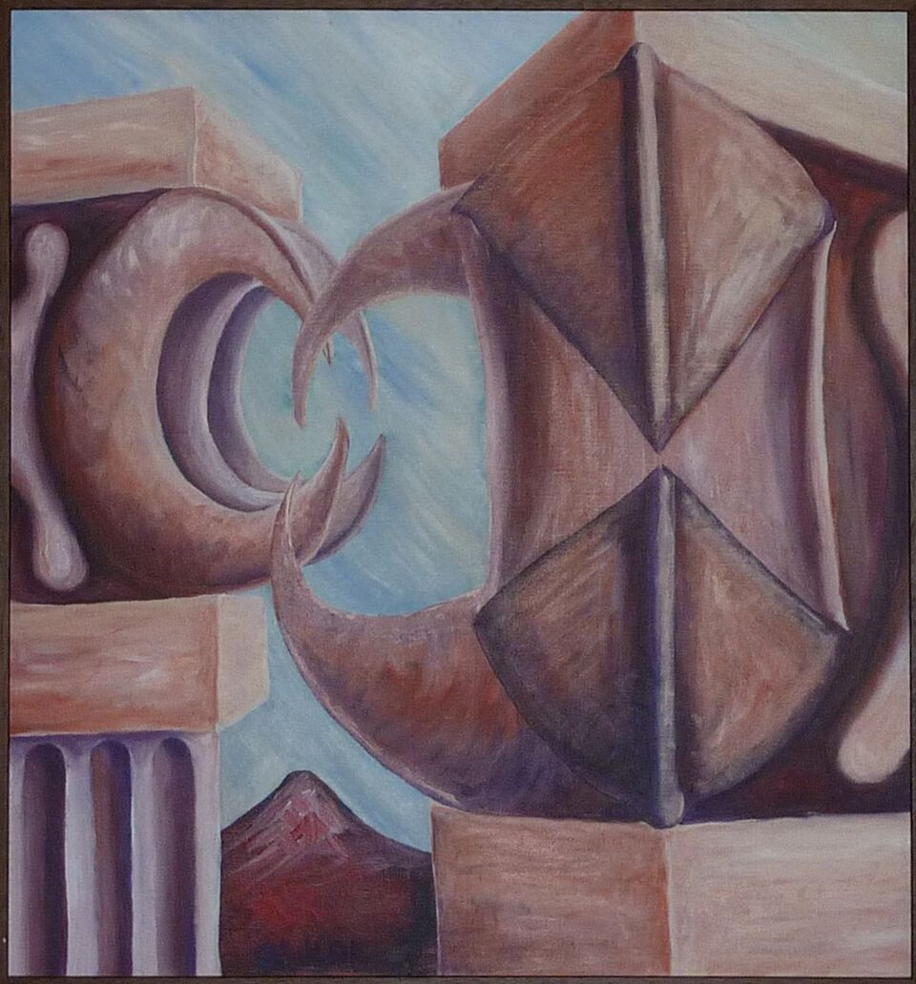
Meditation: Colma Froggatt
Prayer
We pray for those who are living and dying in the war ravaged areas of our world such as Syria.
And we pray for those nearer to home and elsewhere as they grieve the loss of life and damage to their homes and communities.
We remember the deaths of loved ones, and our grief in those losses. We treasure their memories and
cherish the stories of their time with us.
Compassionate God, may we and all the world know your presence.

MUSIC: ‘Kontakion, Depart in Peace’**
Britten, arr & played M Barley (2min 42)

SOLO (with congregational response) HIOS 108 ‘O Christ, you hang upon a cross’
Words: Shirley Murray. Tune: Good Friday, Colin Gibson.
Soloist Jane Keller
O Christ, you hang upon a cross, a cross the world has made,
while soldiers hammer justice out, where games of dice are played.
Kyrie, e-le-i-son, e-le, e-le-i-son. (Twice)

O God, our God, the blood that flows on in suffering’s dark tide,
in battle-zone and marketplace our innocence has died.
Chri-ste e-le-i-son, e-le, e-le-i-son. (Twice)

In private thought, in public stance, we war against your Word,
the law of love is crucified, the lines of evil blurred.
Kyrie, e-le-i-son, e-le, e-le-i-son. (Twice)

O God this day confronts us all who love the world you blessed.
in sorrow and in human shame we lay these griefs to rest.
Chri-ste e-le-i-son, e-le, e-le-i-son. (Twice)

THIRTEENTH STATION – Jesus is taken down from the cross Mark 15: 42-45

Meditation: Pam Ormsby
Prayer
Loving God, be with those who mourn, especially those who have no body and are left wondering. May they find peace in the love and care of family and friends who stand by them. Compassionate God, may we know and all the world your presence.
Sung Response AA151 ‘When human voices cannot sing’ vs 1&3
Words: Shirley Murray. Tune: St Columba, Irish traditional
When human voices cannot sing,
and human hearts are breaking,
we bring our grief to you, O God,
who knows our inner aching.

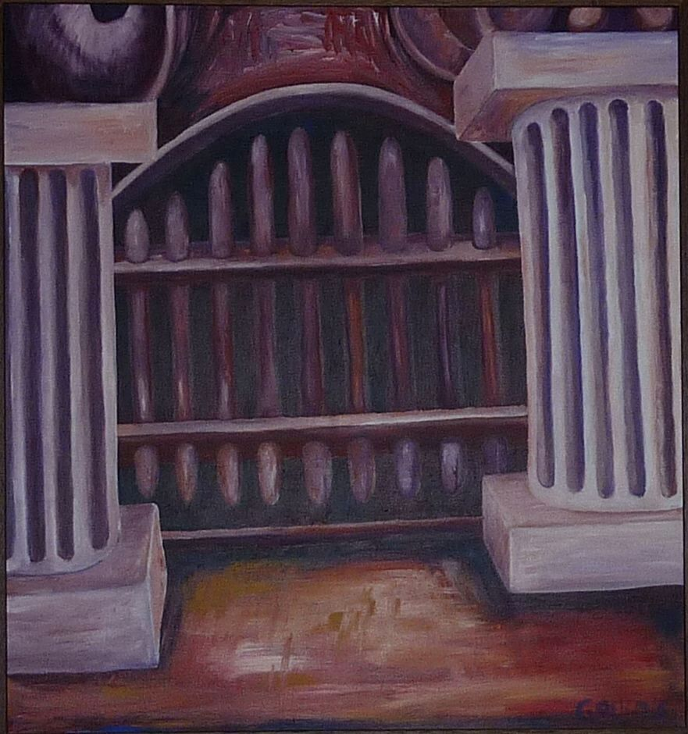
FOURTEENTH STATION – Jesus is laid in the tomb Mark 15: 44-47
Meditation: Ellen Murray

Prayer
We pray for those who are burying victims of persecution, and for those whose hope has been extinguished by the murder of their loved ones.
Compassionate God, may we and all the world know your presence.

Sung Response
Make real for us your holding love,
the love which is your meaning,
the power to move the stone of death,
the hope of Easter morning.

Silence

AFFIRMATION OF FAITH (Please stand) Dorothy McRae-McMahon (adapted)
We believe in God around us,
Dreamer and sustainer of life.
When there was nothing but an ocean of tears,
God sighed over the waters
and dreamed a small dream:
light in the darkness,
a small planet in space.

We believe in God beside us,
In Jesus, the dream made flesh.
When hate and fear were raging,
when love was beaten down,
when hope was nailed and left to die,
He entered into our deep secret places
and went down into our death to find us.

We believe in God within us,
Spirit who empowers the dream.
Who weeps with us in our despair,
who breathes on prison doors,
never admitting it's hopeless,
always expecting the bars to bend and sway
and break forth into flowers.

HYMN ‘We walk in silence’
Words: Bronwyn Angela White.
Tune: Winchester WOV 45
We walk in silence while the earth
quivers and cracks beneath our feet
swallows our dreams and shatters worth
solemn, we trudge to hearts’ dull beat.

We walk while singing, motley choir
of traitors, lovers, meek and proud
small sparks of apostolic fire
light up the path, lighten the shroud.

We walk in solidarity
and sing of hope that never dies
we march to end disparity
graves open as our spirits rise.

We walk the way that has no end
free to evolve, transform our creed
hearts, torn like curtains, start to mend
love rising now in word, in deed.

BLESSING (together)
We go on our way and Jesus goes ahead of us.
We acknowledge our fears, but hold to our trust that God is Love,
that Love is more powerful than fear or death or evil,
and that we are greatly loved.
Let us go out into the world
trusting the power of the spirit of Jesus
who accompanies us through our darkness, pain and uncertainties
towards the joy of our own Easter risings.
Let us go in peace and hope.

MUSIC Concord, Britten, arr & played M Barley (2 min 42) ***

Thanks to Sonia Groes-Petrie for sharing in the preparation and leading of the service, to all participants, to Peter Cowley for the sound and Peter Franklin for the music.

Cello music notes: From Around Britten
* Threnos is a mourning lament. One is used on in the Greek Orthodox Good Friday liturgy, and another is the chant over the body of a close friend. Track 20, 7.12 mins
** Kontakion is based on Russian prayer for the dead. Track 13, 2.42 mins
*** Concord, Track 22, 2.26 mins

